Activity: Interpreting a Radar Precipitation Display

Introduction

Day or night, clear or cloudy, meteorologists need to observe weather at great distances. Radar especially designed for weather observation makes it possible to locate areas of precipitation and to maintain watches on the severity of storms as weather happens.

Weather radars detect water and ice particles in clouds that are large enough to fall as rain, snow, or hail. Their fields of view stretch far beyond the visible horizon, sometimes making known the tops of thunderstorms two hundred miles (over 300 kilometers) away. Their returned signals can be interpreted to determine whether rain or snow is falling, how intense the precipitation is, the size and shape of the precipitation area, the development of it, and how fast and in what direction it is moving. In addition, a trained meteorologist can infer from the radar data the conditions that forewarn the existence of hazardous weather such as tornadoes, heavy downpours, and hurricanes.

From the relationship between the intensity of radar echoes and the rate of rainfall, the total amount of rain at a location can be estimated by computer addition of the rainfall over a period of time. The determination of rainfall totals over an hour, several hours, or even the duration of the storm is important in judging the possibility of flash flooding in a river or stream valley. Flash floods are the greatest weather danger each year in the terms of the number of deaths.

Upon completing this activity, you should be able to:

- locate areas of precipitation by interpreting a radar display.

- track and determine changes over time as precipitation echoes move through a weather radar’s field of view

- relate the intensity of radar echoes to the areas with the greatest amount of rainfall.

The following images represent images from a radar screen of “Reflectivity” views at two successive times during a day (3 p.m. and 4 p.m. local time) when there was precipitation occurring in the radar’s viewing area. The irregular shapes appearing in the image represent precipitation areas. They are contoured and color shaded to denote levels of intensity which correlate to precipitation rates. The intensity scale is located along the upper left portion of each image. The “4 p.m. Precipitation Total” is also shown for the storms from precipitation accumulated between the 3 p.m. and 4
p.m. reflectivity views.

- Look at the 3 p.m. Reflectivity view. The location of the radar is depicted as the dot (●) in the echo shown in the lower right-hand corner. Distance can be measured in

©American Meteorological Society

the horizontal view by the markings appearing along the boundaries of the view at 10-km intervals. Find the strongest echo beyond the one immediately surrounding the radar’s location. How far away and in what direction from the radar site is it?

Also, how many levels of intensity does this echo contain?

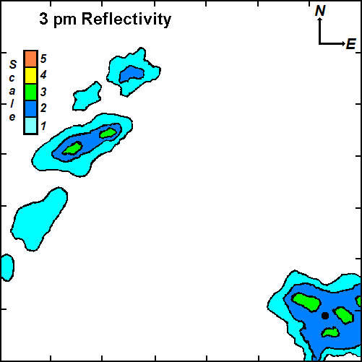

3 p.m. Reflectivity

The centers of the more intense radar echoes are tracked by computer. The individual storm cells are given a storm identification, in this case A and B. The computer projections of future individual storm cell positions are given by a red line denoting the anticipated path. The arrowhead is located at the expected one-hour position. Also given are purple lines that form a wedge of possible variation in position including cross line segments indicating 15 minute increments. These position projections are based on calculations using winds steering the storm cells.
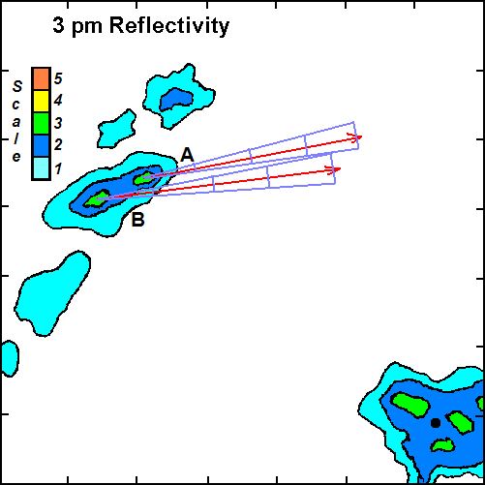

- In what general direction are these most intense cells expected to move over the next hour?

If you were a meteorologist using this radar information, what public warning information might you disseminate?

The 4 p.m. Reflectivity view shows the contoured and shaded precipitation locations at that time. Also, the 3 p.m. Reflectivity positions and the projected movement information are overlaid on the image.
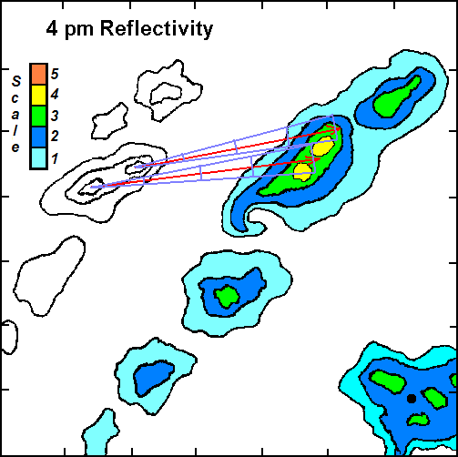

4 p.m. Reflectivity

- Have any of the echoes changed location or shape? If so, which ones?

Is there any echo that did not change? If so, where is it located?

- Near radar sites, it is possible to get intense non-moving echoes because the radar signal is reflected from nearby stationary objects. Do any of your echoes fit this pattern (yes, or no)? If so, what is this echo called?

- Precipitation echoes will continue to move across the radar field of view. In the 4
p.m. view, how many levels of intensity are now contained in the most intense storm? . Generally, the more intense the rain or snow, the greater the shading value. Based on this intensity, the precipitation area experienced [(a decrease)(no change)(an increase)] in rainfall rate.

- From the projected track of the storm cells indicated in the 3 p.m. view and the current position at 4 p.m., how well do you think the computer forecast did?

Are the storm cell positions within the spreads of uncertainty of position?

- Note the curved feature at the southwest end of the most intense cell (located approximately in the center of the view). The curved protrusion occurs when rain is being wrapped around a rapidly rotating column of air. Name this severe weather feature.

If you spotted this feature as a radar operator, what action should you consider taking?

- The entire precipitation area is roughly oriented in a band from southwest to northeast. Such a pattern may be formed from individual storm cells associated along a cold front that is moving toward the southeast. Do individual cells move in the same direction as the line advances? _

In which general direction are the individual cells moving?

If individual thunderstorm cells propagate along the direction of the winds at higher atmospheric levels, what probable direction might the winds at those levels be toward?

- Finally, look at the 4 p.m. Precipitation Total view. The levels in this image according to the scale at the right are total precipitation amounts during the hour (in inches) that have fallen at any location during the time echoes were detected by the radar and rates compiled by the computer. How do the greatest rainfall amounts compare to the most intense reflectivity echoes seen in the 3 p.m. and 4 p.m. views?

- If a hydrologic forecaster has a prior knowledge of streams, local topography, soil moisture conditions and locations of homes and business areas, how would the forecaster use the rainfall information to alert people to possible flood danger?

What factors do you think are important for rainfall runoff?
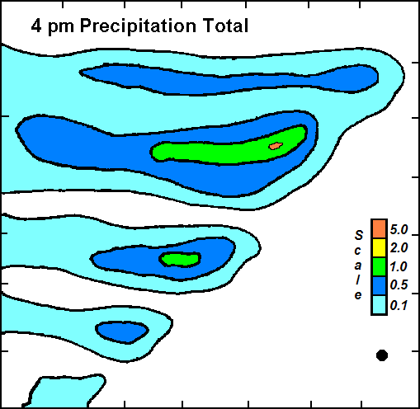

4 p.m. Precipitation Total

Additional Activities:
View radar displays available from the Internet or television. Compare the view with a weather map for the same time. Also, make comparison with satellite images for that same time. What observations can you make for the same locations in the comparison of radar, weather observations and satellite views?

Set up a simulated radar in a darkened classroom. Use a flashlight to represent the radar and hang mobiles of smooth and crumpled aluminum-foil pieces to depict areas of rain or snow. Swing the flashlight beam around or up and down to search for the precipitation areas. Also, try swinging the flashlight around slowly and blink it on an off to simulate the radar pulses. Set up a coordinate system to describe directions and distances to the “echo” sources.

Real World Applications
The following images were from the NWS Forecast Office in Charleston, South Carolina during a precipitation episode, a site in the National Weather Service’s network of radars. (Charleston is actually located on the coast, east of the radar site.) The radar site is identified by a black dot located at the center of each image. Figure 1 is a composite view of the reflectivity image at 2301Z (7:01 p. m. EDT) 13 October 2011 on the left and at 2359Z (7:59 p. m. EDT), almost one hour later, on the right.

Radar reflectivity is a measure of the rate of rainfall shown by the color scale located to the lower right in each image panel. Typically, blues and light greens denote light rainfall, dark greens and yellows are moderate rainfall, and orange and reds are heavy rainfall. Some high reflectivity values can also result from hail within thunderstorms.

- In both reflectivity views there [(is)(is not)] a roughly similar area of generally light reflectivity values about the radar site. This area probably results from
[(intense local rainfall)(ground clutter)]. This area is enhanced in the view on the right as other precipitation activity nears the radar site.

- The more intense orange and red shadings generally [(decreased) (remained the same)(increased)] in area during the hour between views.

- These shadings imply that the overall precipitation over the area has [(decreased) (remained the same)(increased)] in intensity during the hour.

- Draw a line of “best fit” through the orange and red shades in each view. Your lines should be generally oriented southwest to northeast. During the hour, the line of storms has moved generally [(westward)(eastward)].

- In the right image, the brightest red echoes west of the radar site (black dot) display a curved shape on their leading, eastern edges. This shape is called a “bow echo” and frequently is associated with strong, damaging winds. If you were the meteorologist and saw such a radar signature, what actions would you consider taking? .

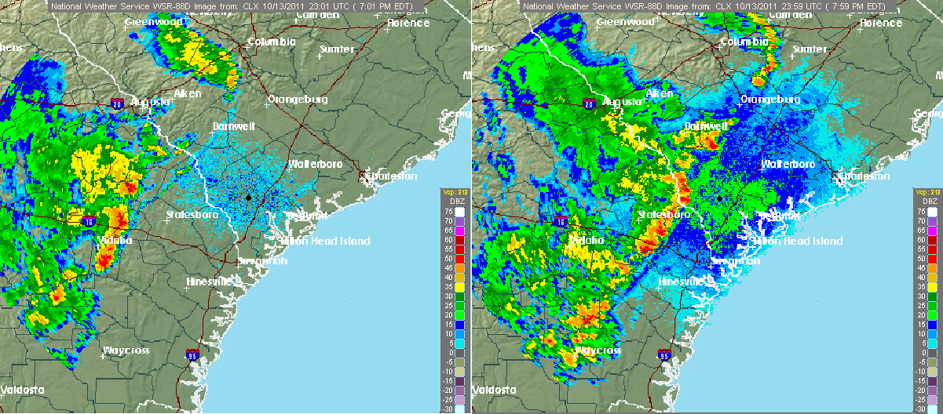

Figure 1. Reflectivity images from the NWS Forecast Office in Charleston, SC at 2301Z (left) and 2359Z (right) of 13 October 2011, respectively.

Figure 2 is the One Hour Precipitation Total from the NWS Charleston radar at 0012Z (8:12 p. m. EDT), a few minutes following the Figure 1 reflectivity image on the right.

- Figure 2 suggests that the most intense precipitation cell(s) traveled generally from
[(west to east)(south to north)].

- Over the hour period, the greatest amount of precipitation (dark blue and green shading) fell to the [(far behind the most intense rainfall)(where the most intense rainfall passed)(far ahead of the most intense rainfall)].
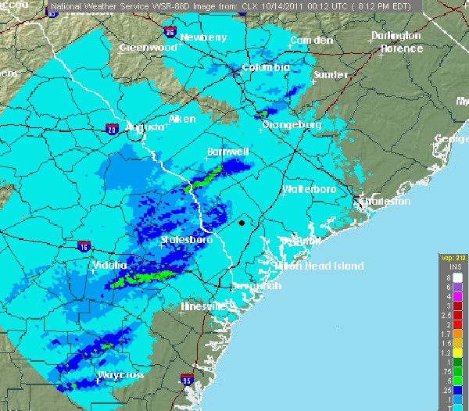

Figure 2. One Hour Precipitation Total from the NWS Charleston radar at 0012Z.

For the latest NWS radar imagery, go to: radar.weather.gov/Conus/. From here regional displays of reflectivities can be selected. Clicking on the U.S. or any regional map will bring you to the local NWS Forecast Office’s radar page. At the station page you can choose the options of Base or Composite Reflectivities, Base or Storm Relative Velocities, and 1-Hour or Storm Total Precipitation amounts. Any of these can also be animated (“looped”). Explore and enjoy, be in the know when weather occurs.

